Welcome to the ’Päikky’ Service

To use the Päikky service, please log in via your web browser on
https://kangasala.paikky.fi

As a guardian, a username has been created for you by the early childhood education unit, based on your mobile phone information. Your identifier is provided in the format 0401234567 (your personal telephone number) and you can start making use of it starting from [day] / [month] / 2017 See below for the instructions for activating your user name.

When your child begins at the early childhood education unit you receive a nfc-tag. Two tag per family. if you need extra tags you can buy then from your early childhood education unit 5 euros each.

How to enter your username when logging in for the first time

You will need to enter your username on https://kangasala.paikky.fi by selecting the option ‘Activate username’.

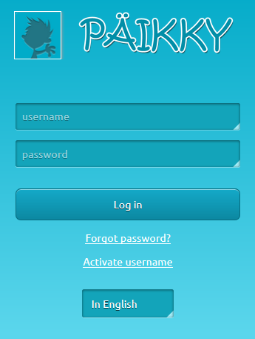
Your mobile phone number, in its Finnish form, i.e. without country code, will act as your user name (e.g. 0401234567).

Once you have entered your username and selected ’send’, you will receive a text message containing a code to the mobile phone number saved in your information at Päikky.

By means of this code you can attach a password to your username, which enables you to log into Päikky.
From then on, you may log into the system by using your user name and password.

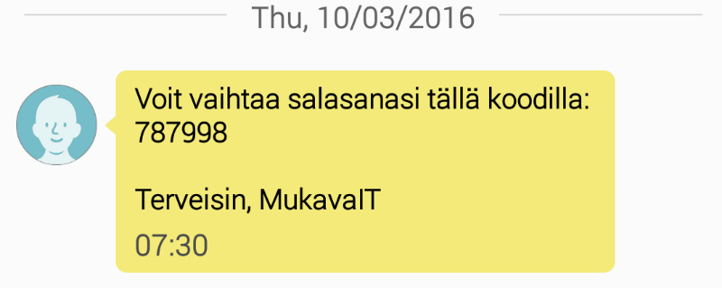

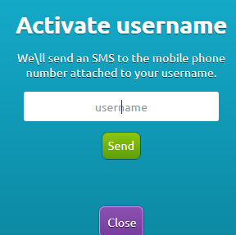

The text message above “Voit vaihtaa salasanasi” tells you that you may change your password by using this code[this message will appear in Finnish].

Notification of care plans and absences

As a guardian, you may notify the daycare electronically regarding absences, as well as the plans for the necessary care time within the next few weeks. The calendar is open until a certain date, with the individual dates varying according to municipality, in which the care reservations for the upcoming week(s) must be made (please check with your child’s own early childhood education group when the calendar closes in your municipality). The calendar will be locked at Wednesday 9 PM upon that date and no notifications may be made after that.

A few important remarks about care time notifications at Päikky:

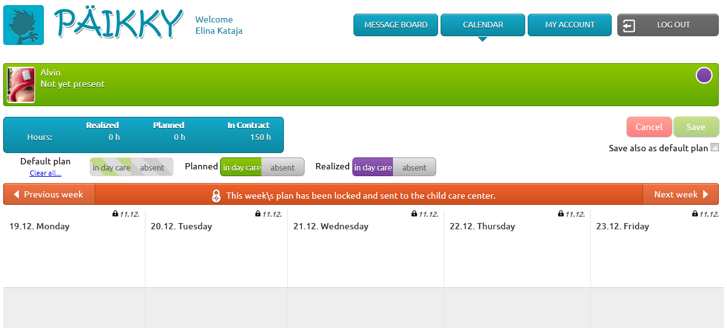

- A plan must be saved individually for each child (one by one, or by copying a plan for several children. For pre-school children you can´t copy other children´s plan)
- The heading for a calendar day will tell you by what date the plans for that day must be notified (whereafter notifications are no longer possible)

- Please plan the need for care for a particular day by selecting ”Add a plan” for each day and then either select ”free” (meaning a free day for the child) or a reservation, with the hours specified.
- Save the plan. You are free to amend and save the plan until the time when the day or week in question is locked.

- You can also save plan as a default plan, if your child is having the same plan all the time.

- You have to make a plan for every children using day care. For example we order meals for children according their plans.

Communication in Päikky

Päikky offers an easy opportunity for communication between the early childhood education unit and guardians.

A few remarks related to communication at Päikky:

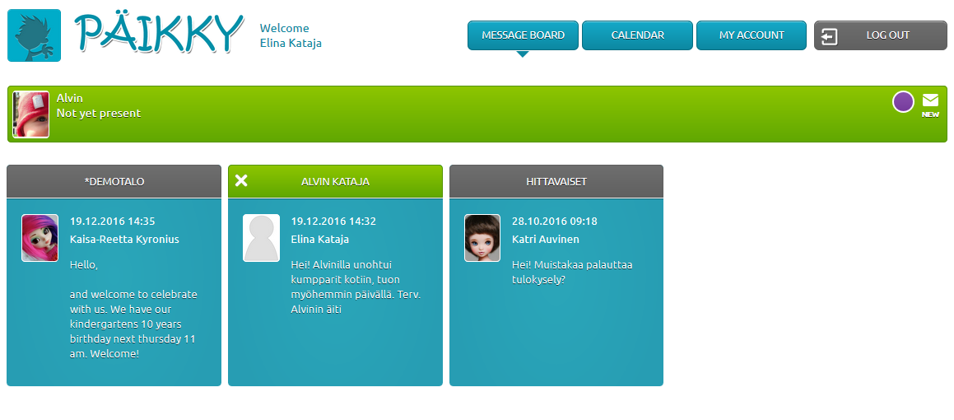
- On the message board you will see the messages concerning all the children in your care at once. The message may relate individually to your child, to your child’s day care group or to the day care centre.
- You may start a new message thread that concerns your own child. All the messages will relate to your own child.
- By selecting a message you gain access to the photographs attached to that message and to the ‘reply’ function. You can only reply to the messages directed to your own child (but not to the ones that were sent on the daycare group or centre level).
- Together with the early childhood education unit you will find a good form of collaboration between the opportunities provided by Päikky messages and your personal communication.

- If an email address was saved in your personal information, you will receive a reminder of the messages received from Päikky.

- For more information go to
http://www.kangasala.fi/lapset_ja_nuoret/varhaiskasvatus/sahkoinen-asiointi-varhaiskasvat/

Käännetty englannin kielelle Pirkanmaan tulkkikeskuksessa 1/2017

